**Experiment 1: Data representation**

**Objective:**

1. To illustrate the concept of data representation

Theory:

**Data representation** refers to the way data is formatted, stored, processed, and transmitted in a computer system. Computers work with electrical signals that can be either "on" or "off," which is typically represented using binary numbers (0s and 1s). The different types of data representation are:

* Binary
* Hexadecimal
* Octal
* 1’s and 2’s complement

**Algorithm:**

i. Start

ii. Initialize a function to find binary 1’s and 2’s complement, hexadecimal, octal

equivalent of number

iii. Input a number to be converted

iv. Find the equivalent numbers

v. Print the binary 1’s and 2’s complement, hexadecimal and octal equivalent

numbers

vi. Stop

**Source code:**

#include<stdio.h>

int conversion(int num, int base)

{

int rem;

if (num == 0)

{

return 1;

}

else

{

rem = num % base;

conversion(num / base, base);

if (base == 16 && rem >= 10)

{

printf("%c", rem + 55);

}

else

{

printf("%d", rem);

}

}

}

int main()

{

int num;

printf("**Compiled By Sanjog Gautam**\n");

printf("Enter the number: ");

scanf("%d", &num);

if(num!=0)

{

printf("The result Binary = ");

conversion(num, 2);

printf("\n");

printf("The result Hexadecimal = ");

conversion(num, 16);

printf("\n");

printf("The result Octal = ");

conversion(num, 8);

printf("\n");

}

else

{

printf("The binary number is=O\n");

printf("The hexadecimal number is=O\n");

printf("The octal number is=O\n");

}

}

Output:

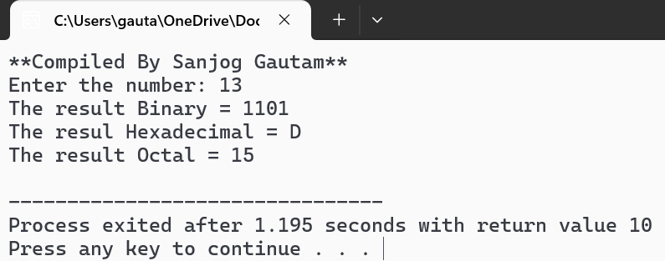

**Source code:**

#include <stdio.h>

int i;

char onesComplement( char num)

{

return ~num;

}

char twosComplement( char num)

{

return onesComplement(num) + 1;

}

void printBinary( char num)

{

for (i = 4; i >= 0; i--)

{

printf("%d", (num >> i) & 1);

}

}

int main()

{

char num;

printf("**Compiled by Sanjog Gautam**\n");

printf("Enter an 4-bit number: ");

scanf("%d", &num);

unsigned char onesComp = onesComplement(num);

unsigned char twosComp = twosComplement(num);

printf("Original number: %d\n", num);

printf("Binary representation of original number: ");

printBinary(num);

printf("\n");

printf("Binary representation of 1's complement: ");

printBinary(onesComp);

printf("\n");

printf("Binary representation of 2's complement: ");

printBinary(twosComp);

printf("\n");

return 0;

}

Output:

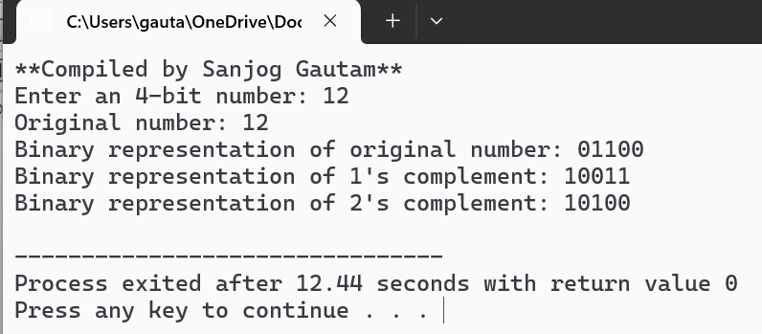

**Experiment 2: Data overflow**

**Objective:**

1. To understand the concept of data overflow

**Theory:**

Overflow occurs when an arithmetic operation or a memory allocation exceeds the capacity of the data type or storage that is available. There are specific conditions under which overflow happens, depending on the type of operation and the data type being used.

**Condition for overflow:**

((AS==BS) &(AS==RS) || (AS! =BS))

{

NO overflow, display result;

}

**Algorithm:**

i. Start

ii. Observe carry into the sign bit position & carry out the sign bit position

iii. If the two carry aren’t equal, overflow should be detected

iv. If the two carry are applied to an X-OR gate overflow will be detected when

output of gate is 1.

v. Stop

**Source code:**

#include <stdio.h>

int main() {

int num1, num2, result,sign1, sign2, signResult;;

printf("**Compiled by Sanjog Gautam**\n")

printf("Enter two 4-bit numbers (0 to 15): ");

scanf("%d%d", &num1, &num2);

result = num1 + num2;

// Extract the 4th bit (sign bit) of each number and the result

sign1 = (num1 >> 3) & 1; // 4th bit of num1

sign2 = (num2 >> 3) & 1; // 4th bit of num2

signResult = (result >> 3) & 1; // 4th bit of result

// Check for overflow

if ((sign1 == sign2 && sign1 != signResult) || (sign1 != sign2 && signResult == 1)) {

printf("\nOverflow detected!\nThe result is: %d\n", result);

} else {

printf("\nNo overflow.\nResult = %d\n", result);

}

return 0;

}

**Output:**

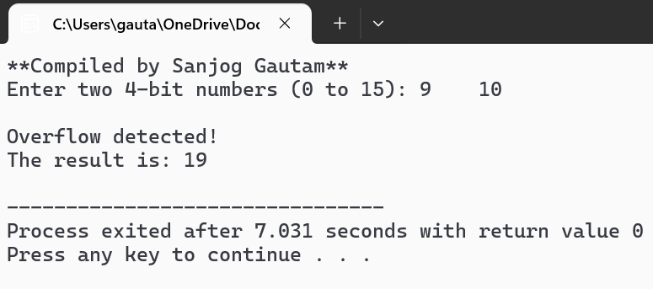

**Experiment 3: Introduction to VHDL**

**Objective:**

1. To implement the Basic gates and universal gates using VHDL

**Theory:**

**VHDL** stands for (**VHSIC Hardware Description Language)**. It is a **hardware description language** used to model and simulate digital systems, such as circuits and systems designed using **VLSI (Very-Large-Scale Integration)** technology. VHDL is used primarily in **designing hardware** and describing its behavior, structure, and timing. In VHDL, entity is used to describe a hardware module. An entity can be described

using:

i. Entity declaration

ii. Architecture

iii. Configuration

iv. Package declaration

v. Package body

**Entity Declaration**:

It defines the name, input/output signals and modes of hardware module.

Syntax:

entity entity_name is

port declaration;

end entity_name;

Architecture:

Can be described using structural, data flow, behavior or mixed type.

Syntax:

architecture architecture_name of entity_name is

architecture architecture_declarative part;

begin

statements;

end architecture_name;

logic operation: N

**Experiment i: Introduction to VHDL**

**Objective:**

1. To implement the AND gate using VHDL

**Theory:**

An AND gate is a basic digital logic gate that implements logical conjunction—meaning it outputs true (or 1) only if all its inputs are true (or 1). If at least one input is false (or 0), the output will be false (or 0). The AND gate is one of the fundamental building blocks in digital electronics.

**Truth Table for AND Gate:**

|  |  |  |
| --- | --- | --- |
| **Input A** | **Input B** | **Output (A AND B)** |
| 0 | 0 | 0 |
| 0 | 1 | 0 |
| 1 | 0 | 0 |
| 1 | 1 | 1 |

**Source code:** For and gate

**Testbench:**

-- Testbench for AND gate

library IEEE;

use IEEE.std_logic_1164.all;

entity testbench is

-- empty

end testbench;

architecture tb of testbench is

-- DUT component

component and_gate is

port(

a: in std_logic;

b: in std_logic;

q: out std_logic);

end component;

signal a_in, b_in, q_out: std_logic;

begin

-- Connect DUT

DUT: and_gate port map(a_in, b_in, q_out);

process

begin

a_in <= '0';

b_in <= '0';

wait for 10 ns;

a_in <= '0';

b_in <= '1';

wait for 10 ns;

a_in <= '1';

b_in <= '0';

wait for 10 ns;

a_in <= '1';

b_in <= '1';

wait for 10 ns;

-- Clear inputs

a_in <= '0';

b_in <= '0';

wait for 20 ns;

end process;

end tb;

**Architecture:**

-- Simple AND gate design

library IEEE;

use IEEE.std_logic_1164.all;

entity and_gate is

port(

a: in std_logic;

b: in std_logic;

q: out std_logic);

end and_gate;

architecture rtl of and_gate is

begin

process(a, b) is

begin

q <= a and b;

end process;

end rtl;

**Output:**

**Experiment ii: Half adder**

**Objective:**

1. To implement the Half adder using VHDL

**Theory:**

A half adder is a basic digital circuit used to add two single-bit binary numbers. It has two inputs, typically labeled A and B, and two outputs: the sum (S) and the carry (C).

* **Sum (S)**: This is the result of the bitwise addition of A and B, without considering any carry from a previous operation. It can be found using the XOR (exclusive OR) operation.
* **Carry (C)**: This is the carry-out bit, which is generated when both A and B are 1, meaning there is an overflow into the next higher bit. It can be found using the AND operation.

**Truth table**:

|  |  |  |  |
| --- | --- | --- | --- |
| A | B | Sum(S) | Carry(C) |
| 0 | 0 | 0 | 0 |
| 0 | 1 | 1 | 0 |
| 1 | 0 | 1 | 0 |
| 1 | 1 | 0 | 1 |

**Source code:**

**Testbench:**

-- Testbench for half adder gate

library IEEE;

use IEEE.std_logic_1164.all;

entity testbench is

-- empty

end testbench;

architecture tb of testbench is

-- DUT component

component halfadder_gate is

port(

a: in std_logic;

b: in std_logic;

sum: out std_logic;

carry:out std_logic);

end component;

signal a_in, b_in, sum_out, carry_out: std_logic;

begin

-- Connect DUT

DUT: halfadder_gate port map(a_in, b_in, sum_out, carry_out);

process

begin

a_in <= '0';

b_in <= '0';

wait for 10 ns;

a_in <= '0';

b_in <= '1';

wait for 10 ns;

a_in <= '1';

b_in <= '0';

wait for 10 ns;

a_in <= '1';

b_in <= '1';

wait for 10 ns;

-- Clear inputs

a_in <= '0';

b_in <= '0';

wait for 20 ns;

end process;

end tb;

**Architecture:**

-- Simple half adder gate design

library IEEE;

use IEEE.std_logic_1164.all;

entity halfadder_gate is

port(

a: in std_logic;

b: in std_logic;

sum: out std_logic;

carry:out std_logic);

end halfadder_gate;

architecture rtl of halfadder_gate is

begin

process(a, b) is

begin

sum <= a xor b;

carry <= a and b;

end process;

end rtl;

**Output:**

**Experiment ii: Full adder**

**Objective:**

1. To implement the Full adder using VHDL

**Theory:** A **Full Adder** is a digital circuit that computes the sum of three binary inputs: two **operands** and a **carry-in** bit. It produces a **sum** and a **carry-out** bit.

The Full Adder is an extension of the **Half Adder**, which only adds two binary bits. In the Full Adder, we also consider a carry from the previous addition, making it more suitable for multi-bit binary addition, such as adding numbers in computer arithmetic. The output of full adder are:

1. **Sum (S)** (The result of adding A, B, and Carry-in)
2. **Carry-out (Cout)** (Carry to the next bit position)

Truth table:

|  |  |  |  |  |
| --- | --- | --- | --- | --- |
| **A** | **B** | **Cin** | **Sum(S)** | **Carry(Cout)** |
| 0 | 0 | 0 | 0 | 0 |
| 0 | 0 | 1 | 1 | 0 |
| 0 | 1 | 0 | 1 | 0 |
| 0 | 1 | 1 | 0 | 1 |
| 1 | 0 | 0 | 1 | 0 |
| 1 | 0 | 1 | 0 | 1 |
| 1 | 1 | 0 | 0 | 1 |
| 1 | 1 | 1 | 1 | 1 |

**Source code:**

-- Testbench for fulladder gate

library IEEE;

use IEEE.std_logic_1164.all;

entity testbench is

-- empty

end testbench;

architecture tb of testbench is

-- DUT component

component fulleladder_gate is

port(

a: in std_logic_vector(3 downto 0);

b: in std_logic_vector(3 downto 0);

c:in std_logic;

sum: out std_logic_vector(3 downto 0);

carry:out std_logic);

end component;

signal a_in,b_in:std_logic_vector, c_in:std_logic;

signal sum_out:std_logic_vector(3 downto 0),carry_out:std_logic;

begin

-- Connect DUT

DUT: fulladder_gate port map(a_in, b_in, c_in, sum_out, carry_out);

process

begin

a_in <= '0';

b_in <= '0';

c_in <= '0';

wait for 10 ns;

a_in <= '0';

b_in <= '0';

c_in <= '1';

wait for 10 ns;

a_in <= '0';

b_in <= '1';

c_in <= '0';

wait for 10 ns;

a_in <= '0';

b_in <= '1';

c_in <= '1';

wait for 10 ns;

a_in <= '1';

b_in <= '0';

c_in <= '0';

wait for 10 ns;

a_in <= '1';

b_in <= '0';

c_in <= '1';

wait for 10 ns;

a_in <= '1';

b_in <= '1';

c_in <= '0';

wait for 10 ns;

a_in <= '1';

b_in <= '1';

c_in <= '1';

wait for 10 ns;

-- Clear inputs

a_in <= '0';

b_in <= '0';

c_in <= '0';

wait for 20 ns;

end process;

end tb;

**Architecture:**

-- Simple fulladder gate design

library IEEE;

use IEEE.std_logic_1164.all;

entity fulladder_gate is

port(

a: in std_logic;

b: in std_logic;

c: in std_logic;

sum: out std_logic;

carry:out std_logic);

end fulladder_gate;

architecture rtl of fulladder_gate is

begin

process(a, b, c) is

begin

sum <= a xor b xor c;

carry <= (a and b) or (a and c) or (b and c);

end process;

end rtl;

**Output:**

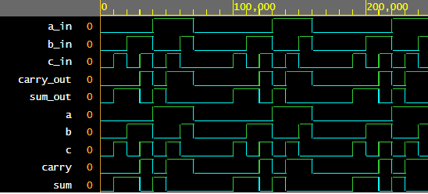

**Experiment iv: 4-bit parallel adder**

**Objective:**

1. To implement the 4-bit parallel adder using VHDL

**Theory:**

A **4-bit parallel adder** is a digital circuit that adds two 4-bit binary numbers simultaneously, producing a 4-bit sum and a carry-out bit. It is made up of multiple **full adders** connected in parallel. Each full adder in the circuit adds corresponding bits of the two 4-bit inputs, along with any carry from the previous stage.

**Architecture:**

-- Simple paralleladder gate design

library IEEE;

use IEEE.std_logic_1164.all;

entity paralleladder_gate is

port(

a: in std_logic_vector(3 downto 0);

b: in std_logic_vector(3 downto 0);

c: in std_logic;

sum: out std_logic_vector(3 downto 0);

carry:out std_logic);

end paralleladder_gate;

architecture rtl of paralleladder_gate is

begin

process(a, b, c) is

variable temp: std_logic;

begin

temp:= c;

for i in 0 to 3 loop

sum(i) <= a(i) xor b(i) xor temp;

temp:=(a(i) and B(i)) or (temp and a(i)) or (temp and b(i));

end loop;

carry<=temp;

end process;

end rtl;

**Source code:**

-- Testbench for paralleladder gate

library IEEE;

use IEEE.std_logic_1164.all;

entity testbench is

-- empty

end testbench;

architecture tb of testbench is

-- DUT component

component paralleladder_gate is

port(

a: in std_logic_vector(3 downto 0);

b: in std_logic_vector(3 downto 0);

c:in std_logic;

sum: out std_logic_vector(3 downto 0);

carry:out std_logic);

end component;

signal a_in,b_in:std_logic_vector(3 downto 0):=(others=>'0'); signal c_in:std_logic;

signal sum_out:std_logic_vector(3 downto 0):= (others=>'0');

signal carry_out:std_logic;

begin

-- Connect DUT

DUT: paralleladder_gate port map(a_in, b_in, c_in, sum_out, carry_out);

process

begin

--test 1

a_in <="0011";

b_in <="1111";

c_in <='0';

wait for 10 ns;

--test 2

a_in <="0011";

b_in <="1100";

c_in <='1';

wait for 10 ns;

--test 3

a_in<="0101";

b_in <="1010";

c_in <='1';

wait for 20 ns;

end process;

end tb;

**Output:**

**Experiment v: Encoder**

**Objective:**

1. To implement encoder using VHDL

**Theory:**

An **encoder** is a digital circuit that converts data from one format or code to another, typically from a larger set of inputs to a smaller set of outputs. In the context of binary systems, an encoder is a device that converts an active input line into a binary code corresponding to that input.

For example, in a **binary encoder**, the number of output bits is fewer than the number of input lines. The encoder "encodes" the input into a binary number representing the position of the active input line.

**Architecture:**

library IEEE;

use IEEE.STD_LOGIC_1164.ALL;

entity Encoder4_2 is

Port ( a: in STD_LOGIC_VECTOR (3 downto 0);

b: out STD_LOGIC_VECTOR (1 downto 0));

end Encoder4_2;

architecture rtl of Encoder4_2 is

begin

process(a)

begin

if (a="0001") then

b <= "00";

elsif (a="0010") then

b <= "01";

elsif (a="0100") then

b <= "10";

elsif (a="1000") then

b <= "11";

else

b <= "ZZ";

end if;

end process;

end rtl;

**Source code:**

Encoder:

library IEEE;

use IEEE.STD_LOGIC_1164.ALL;

ENTITY Encoder_test IS

END Encoder_test;

ARCHITECTURE behavior OF Encoder_test IS

COMPONENT Encoder4_2

PORT (a: IN std_logic_vector(3 downto 0);

b: OUT std_logic_vector(1 downto 0)

);

END COMPONENT;

signal a: std_logic_vector(3 downto 0) := (others => '0');

signal b: std_logic_vector(1 downto 0);

BEGIN

uut: Encoder4_2 PORT MAP (a => a,b => b);

process

begin

wait for 100 ns;

a <= "0000";

wait for 100 ns;

a <= "0001";

wait for 100 ns;

a <= "0010";

wait for 100 ns;

a <= "0100";

wait for 100 ns;

a <= "1000";

wait;

end process;

end;

**Output:**

**Experiment vi: ALU**

**Objective:**

1. To implement ALU using VHDL

**Theory:**

The Arithmetic and Logical unite is the fundamental component in a computing system like a computer. It is basically the actual data processing element within the central processing unit (CPU) in a computing system. It performs all the arithmetic and logical operations and forms the backbone of modern computer technology.

**Architecture:**

**--**design for alu

library IEEE;

use IEEE.STD_LOGIC_1164.ALL;

use IEEE.STD_LOGIC_UNSIGNED.ALL;

use ieee.NUMERIC_STD.all;

entity ALU is

generic ( constant N: natural:=1); -- number of shifted or rotated bits

Port (

A, B: in STD_LOGIC_VECTOR (7 downto 0); -- 2 inputs 8-bit

ALU_Sel: in STD_LOGIC_VECTOR (3 downto 0); -- 1 input 4-bit for selecting function

ALU_Out: out STD_LOGIC_VECTOR (7 downto 0); -- 1 output 8-bit

Carryout: out std_logic; -- Carryout flag

);

end ALU;

architecture Behavioral of ALU is

signal ALU_Result: std_logic_vector (7 downto 0);

signal tmp: std_logic_vector (8 downto 0);

begin

process(A,B,ALU_Sel)

begin

case(ALU_Sel) is

when "0000" => -- Addition

ALU_Result <= A + B ;

when "0001" => -- Subtraction

ALU_Result <= A - B ;

when "0010" => -- Multiplication

ALU_Result<=std_logic_vector(to_unsigned((to_integer(unsigned(A)) *

to_integer(unsigned(B))),8)) ;

when "0011" => -- Division

ALU_Result <= std_logic_vector(to_unsigned(to_integer(unsigned(A)) /

to_integer(unsigned(B)),8)) ;

when "0100" => -- Logical shift left

ALU_Result <= std_logic_vector(unsigned(A) sll N);

when "0101" => -- Logical shift right

ALU_Result <= std_logic_vector(unsigned(A) srl N);

when "0110" => -- Rotate left

ALU_Result <= std_logic_vector(unsigned(A) rol N);

when "0111" => -- Rotate right

ALU_Result <= std_logic_vector(unsigned(A) ror N);

when "1000" => -- Logical and

ALU_Result <= A and B;

when "1001" => -- Logical or

ALU_Result <= A or B;

when "1010" => -- Logical xor

ALU_Result <= A xor B;

when "1011" => -- Logical nor

ALU_Result <= A nor B;

when "1100" => -- Logical nand

ALU_Result <= A nand B;

when "1101" => -- Logical xnor

ALU_Result <= A xnor B;

when "1110" => -- Greater comparison

if(A>B) then

ALU_Result <= x"01" ;

else

ALU_Result <= x"00" ;

end if;when "1111" => -- Equal comparison

if(A=B) then

ALU_Result <= x"01" ;

else

ALU_Result <= x"00" ;

end if;

when others => ALU_Result <= A + B ;

end case;

end process;

ALU_Out <= ALU_Result; -- ALU out

tmp <= ('0' & A) + ('0' & B);

Carryout <= tmp(8); -- Carryout flag

end Behavioral;

**Source code:**

-- Testbench for alu adder

library IEEE;

use IEEE.std_logic_1164.all;

entity testbench is

-- empty

end testbench;

architecture tb of testbench is

-- DUT component

component ALU is

Port (

A, B: in STD_LOGIC_VECTOR (7 downto 0); -- 2 inputs 8-bit

ALU_Sel: in STD_LOGIC_VECTOR (3 downto 0); -- 1 input 4-bit for selecting function

ALU_Out: out STD_LOGIC_VECTOR (7 downto 0); -- 1 output 8-bit

Carryout: out std_logic; -- Carryout flag

);

end component;

signal A, B: std_logic_vector(7 downto 0);

signal ALU_Sel: std_logic_vector(3 downto 0);

signal ALU_out: std_logic_vector(7 downto 0);

signal Carryout: std_logic;

begin

-- Connect DUT

DUT: ALU

port map (

A => A,

B => B,

ALU_Sel => ALU_Sel,

ALU_out => ALU_out,

Carryout => Carryout

);

-- Test process

process

begin

-- Test cases

A <= "00001111";

B <= "00001100";

ALU_Sel<= "0000";

wait for 10 ns; -- Expected output: S_out = "0000", Cout_out = '0'

A <= "00001011";

B <= "00000110";

ALU_Sel <= "0001";

wait for 10 ns; -- Expected output: S_out = "0010", Cout_out = '0'

A <= "00000100";

B <= "00000011";

ALU_Sel <= "0010";

wait for 10 ns;

A <= "00001000";

B <= "00000100";

ALU_Sel <= "0011";

wait for 10 ns;

-- End of simulation

wait for 20 ns;

assert false report "End of simulation" severity failure;

end process;

end tb;

**Output:**

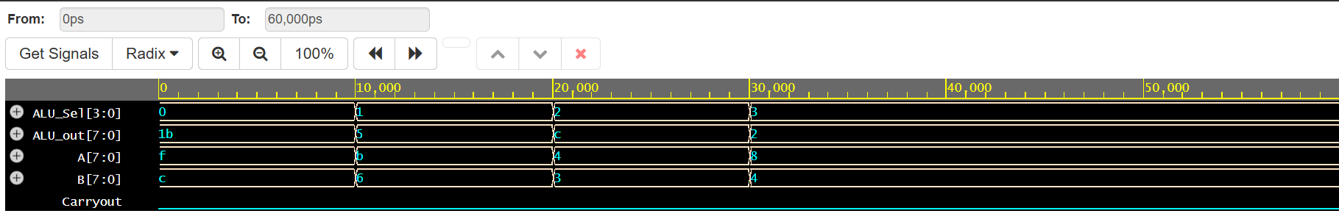

**Conclusion:**

In conclusion, designing an ALU in VHDL enables efficient implementation of arithmetic and logic operations in digital systems. VHDL's flexibility and modularity allow for easy testing, simulation, and refinement, ensuring reliable performance. It is a powerful tool for creating high-performance, cost-effective hardware designs.

**Experiment vii: 3-Segment Pipeline**

**Objective:**

1. To implement 3-Segment Pipeline using VHDL

**Theory:**

The Arithmetic and Logical unite is the fundamental component in a computing system like a computer. It is basically the actual data processing element within the central processing unit (CPU) in a computing system. It performs all the arithmetic and logical operations and forms the backbone of modern computer technology.

**Architecture:**

--design for pipeline

library IEEE;

use IEEE.STD_LOGIC_1164.ALL;

use IEEE.NUMERIC_STD.ALL;

entity pipeline is

Port (

a : in integer;

b : in integer;

c : in integer;

clk : in STD_LOGIC;

y : out integer

);

end pipeline;

architecture Behavioral of pipeline is

signal r1, r2, r3, r4, r5 : integer := 0;

begin

y <= r5;

process(clk)

begin

if rising_edge(clk) then

-- Pipeline stage 1

r1 <= a;

r2 <= b;

-- Pipeline stage 2 (registered)

r4 <= r1 + r2;

r3 <= c;

-- Pipeline stage 3 (registered)

r5 <= r4 * r3;

end if;

end process;

end Behavioral;

**Source code:**

--testbench for pipeline

library IEEE;

use IEEE.STD_LOGIC_1164.ALL;

use IEEE.NUMERIC_STD.ALL;

entity pipeline_tb is

end pipeline_tb;

architecture Behavioral of pipeline_tb is

component pipeline

Port (

a : in integer;

b : in integer;

c : in integer;

clk : in STD_LOGIC;

y : out integer

);

end component;

signal a, b, c : integer := 0;

signal y : integer;

signal clk : STD_LOGIC := '0';

constant clk_period : time := 10 ns;

begin

uut: pipeline port map (

a => a,

b => b,

c => c,

clk => clk,

y => y

);

-- Clock generation

clk_process: process

begin

clk <= '0';

wait for clk_period/2;

clk <= '1';

wait for clk_period/2;

end process;

-- Stimulus process

stim_proc: process

begin

-- Test case 1

a <= 2;

b <= 3;

wait for 3 ns;

c <= 4;

wait for clk_period*2;

-- Test case 2

a <= 5;

b <= 6;

wait for 5 ns;

c <= 7;

wait for clk_period*2;

-- Test case 3

a <= 10;

b <= 20;

wait for 5 ns;

c <= 30;

wait for clk_period*2;

-- End simulation

wait;

end process;

end Behavioral;

**Output:**

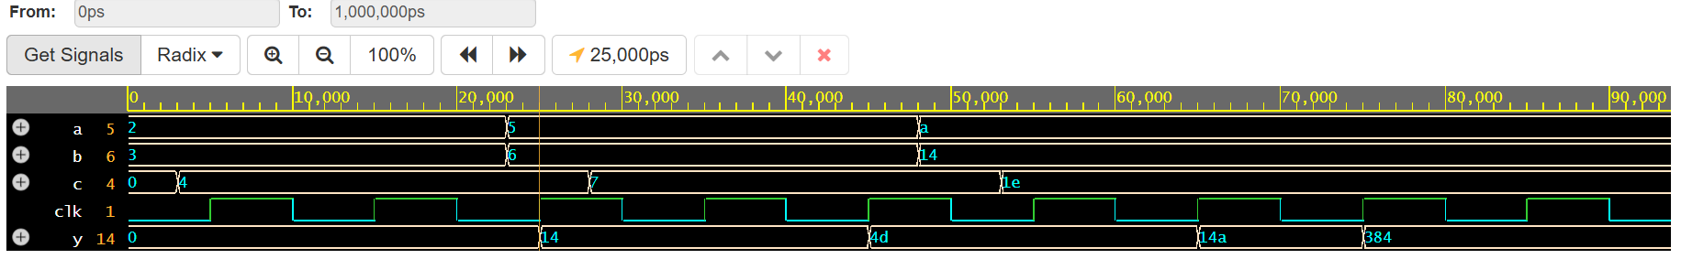

**Conclusion:**

In conclusion, implementing a 3-segment pipeline in VHDL enhances system performance by allowing parallel processing of data in stages. This approach increases throughput and reduces latency by efficiently organizing tasks across different pipeline segments. VHDL provides the necessary tools to model, simulate, and optimize the pipeline, ensuring smooth operation and scalability in complex digital systems.

**Experiment 4: Booth’s Multiplication Algorithm**

**Objective:**

1. To implement Booth’s Multiplication Algorithm.

**Theory:**

**Hardware Implementation**

It needs same hardware as that of addition and subtraction of signed-magnitude. In addition, it needs two more registers Q and SC.

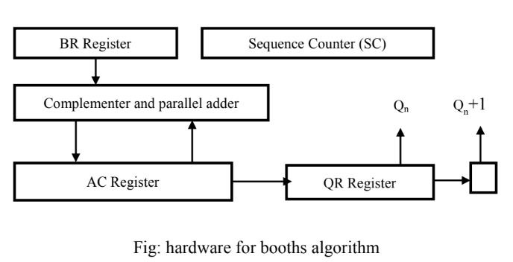

**Algorithm:**

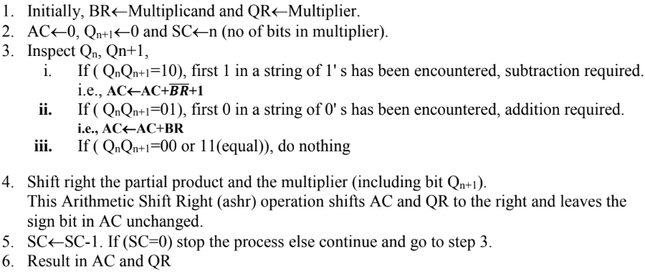

**Flowchart:**

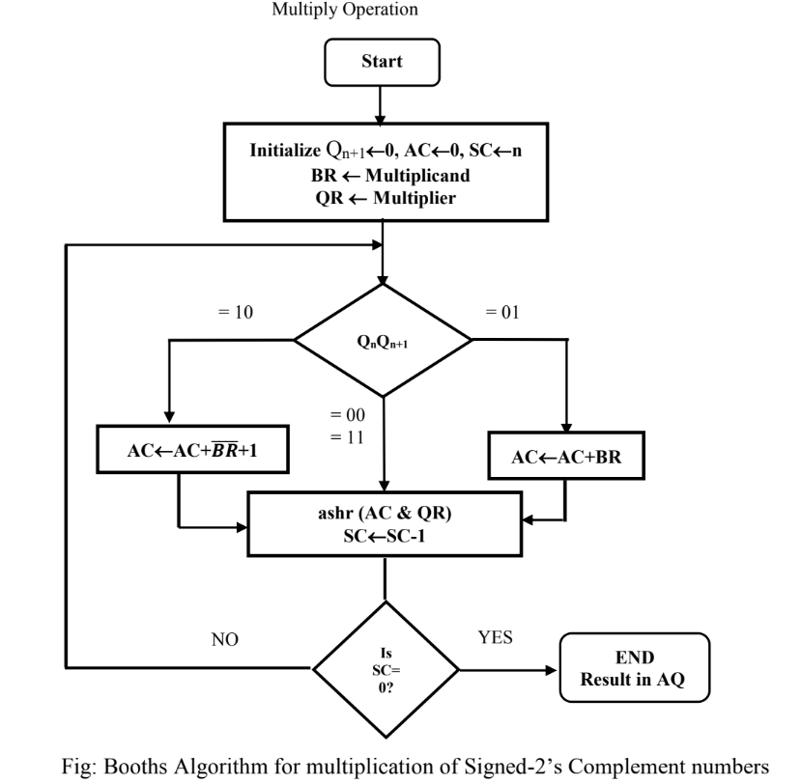

#include<iostream>

using namespace std;

void add(int a[], int x[], int q);

void complement(int a[], int n) {

int i;

int x[8] = { NULL };

x[0] = 1;

for (i = 0; i < n; i++) {

a[i] = (a[i] + 1) % 2;

}

add(a, x, n);

}

void add(int ac[], int x[], int q) {

int i, c = 0;

for (i = 0; i < q; i++) {

ac[i] = ac[i] + x[i] + c;

if (ac[i] > 1) {

ac[i] = ac[i] % 2;

c = 1;

}else

c = 0;

}

}

void ashr(int ac[], int qr[], int &qn, int q) {

int temp, i;

temp = ac[0];

qn = qr[0];

cout << "\t\tashr\t\t";

for (i = 0; i < q - 1; i++) {

ac[i] = ac[i + 1];

qr[i] = qr[i + 1];

}

qr[q - 1] = temp;

}

void display(int ac[], int qr[], int qrn) {

int i;

for (i = qrn - 1; i >= 0; i--)

cout << ac[i];

cout << " ";

for (i = qrn - 1; i >= 0; i--)

cout << qr[i];

}

int main(int argc, char **argv) {

int mt[10], br[10], qr[10], sc, ac[10] = { 0 };

int brn, qrn, i, qn, temp;

cout<<"**Booth Algorithm Compiled by Sanjog Gautam**\n"<<endl;

cout << "\n Number of multiplicand bit=";

cin >> brn;

cout << "\nmultiplicand=";

for (i = brn - 1; i >= 0; i--)

cin >> br[i]; //multiplicand

for (i = brn - 1; i >= 0; i--)

mt[i] = br[i];

complement(mt, brn);

cout << "\nNo. of multiplier bit=";

cin >> qrn;

sc = qrn;

cout << "Multiplier=";

for (i = qrn - 1; i >= 0; i--)

cin >> qr[i];

qn = 0;

temp = 0;

cout << "qn\tq[n+1]\t\tBR\t\tAC\tQR\t\tsc\n";

cout << "\t\t\tinitial\t\t";

display(ac, qr, qrn);

cout << "\t\t" << sc << "\n";

while (sc != 0) {

cout << qr[0] << "\t" << qn;

if ((qn + qr[0]) == 1) {

if (temp == 0) {

add(ac, mt, qrn);

cout << "\t\tsubtracting BR\t";

for (i = qrn - 1; i >= 0; i--)

cout << ac[i];

temp = 1;

}

else if (temp == 1) {

add(ac, br, qrn);

cout << "\t\tadding BR\t";

for (i = qrn - 1; i >= 0; i--)

cout << ac[i];

temp = 0;

}

cout << "\n\t";

ashr(ac, qr, qn, qrn);

}

else if (qn - qr[0] == 0)

ashr(ac, qr, qn, qrn);

display(ac, qr, qrn);

cout << "\t";

sc--;

cout << "\t" << sc << "\n";

}

cout << "Result=";

display(ac, qr, qrn);}

**Output:**

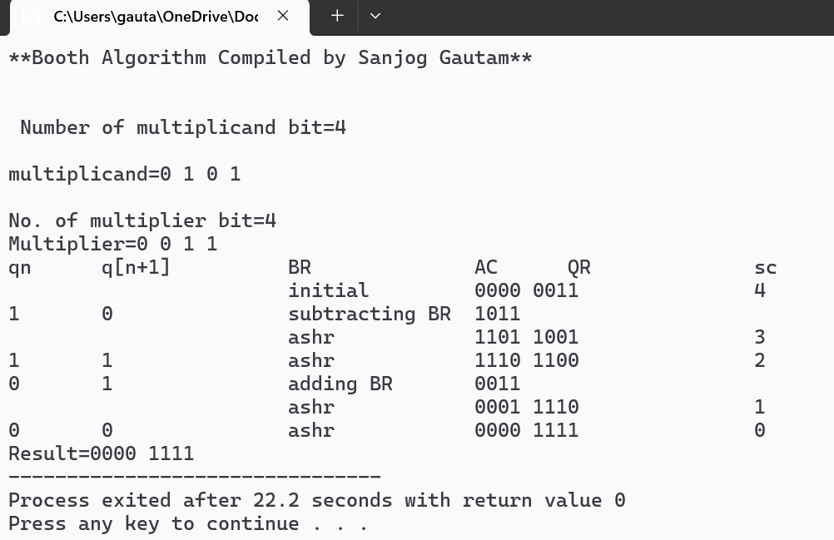

**Conclusion:**

Booth’s Algorithm is an efficient way to multiply signed binary numbers using shifts and additions. It handles both positive and negative inputs with ease and mimics how real hardware performs multiplication

**Experiment 5: Restoring Division Algorithm**

**Objective:**

1. To implement Restoring Division Algorithm.

**Theory:**

**Hardware Implementation**

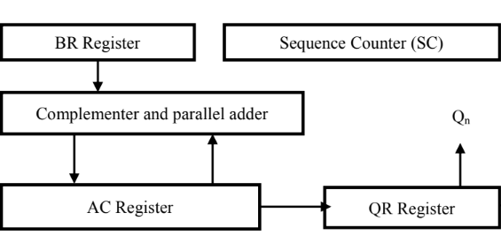

**Algorithm:**

**Step 1:** Initialize A, Q and M registers to zero, dividend and divisor respectively and counter to

n where n is the number of bits in the dividend.

**Step 2:** Shift A, Q left one binary position.

**Step 3:** Subtract M from A placing answer back in A. If sign of A is 1, set Q to zero and add M

back to A (restore A). If sign of A is 0, set Q to 1.

**Step 4:** Decrease counter; if counter > 0, repeat process from step 2 else stop the process. The

final remainder will be in A and quotient will be in Q.

**Flowchart:**

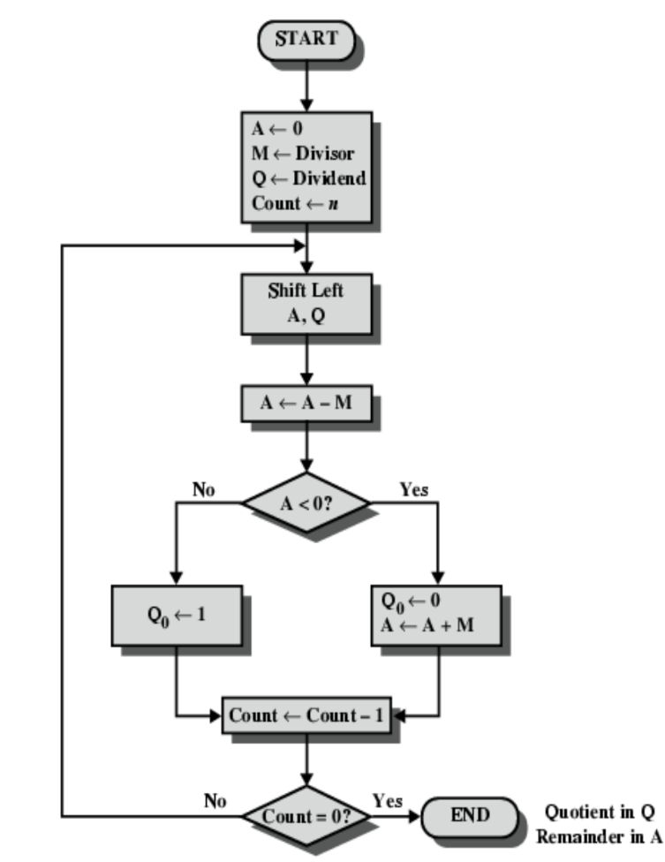

**Source code:**

#include <stdio.h>

void print_binary(int num, int bits) {

int i;

for (i = bits - 1; i >= 0; i--) {

printf("%d", (num >> i) & 1);

}

}

void print_step(int step, const char* op, int A, int Q, int bits) {

printf("| %2d | %-12s | ", step, op);

print_binary(A, bits);

printf(" | ");

print_binary(Q, bits);

printf(" |\n");

}

int main() {

int dividend, divisor;

int bits = 4;

int A, Q, M;

int step;

printf("**Restoring Algorithm By Sanjog Gautam**\n");

printf("Restoring Division Algorithm (4-bit)\n");

printf("Enter dividend (0-15): ");

scanf("%d", &dividend);

printf("Enter divisor (0-15): ");

scanf("%d", &divisor);

A = 0;

Q = dividend;

M = divisor;

step = bits;

printf("\n+----+--------------+--------+--------+\n");

printf("|Step| Operation | A | Q |\n");

printf("+----+--------------+--------+--------+\n");

print_step(step, "Initial", A, Q, bits);

for (step = bits; step > 0; step--) {

// Shift AQ left

A = (A << 1) | ((Q >> (bits-1)) & 1);

Q <<= 1;

print_step(step, "Shift AQ", A, Q, bits);

// Subtract M from A

A -= M;

print_step(step, "A = A - M", A, Q, bits);

if (A < 0) {

A += M; // Restore

print_step(step, "Restore A", A, Q, bits);

} else {

Q |= 1; // Set LSB

print_step(step, "Set Q0=1", A, Q, bits);

}

}

printf("+----+--------------+--------+--------+\n");

printf("\nResult: Quotient = %d, Remainder = %d\n", Q & 0xF, A & 0xF); // Mask to 4 bits

return 0;

}

**Output:**

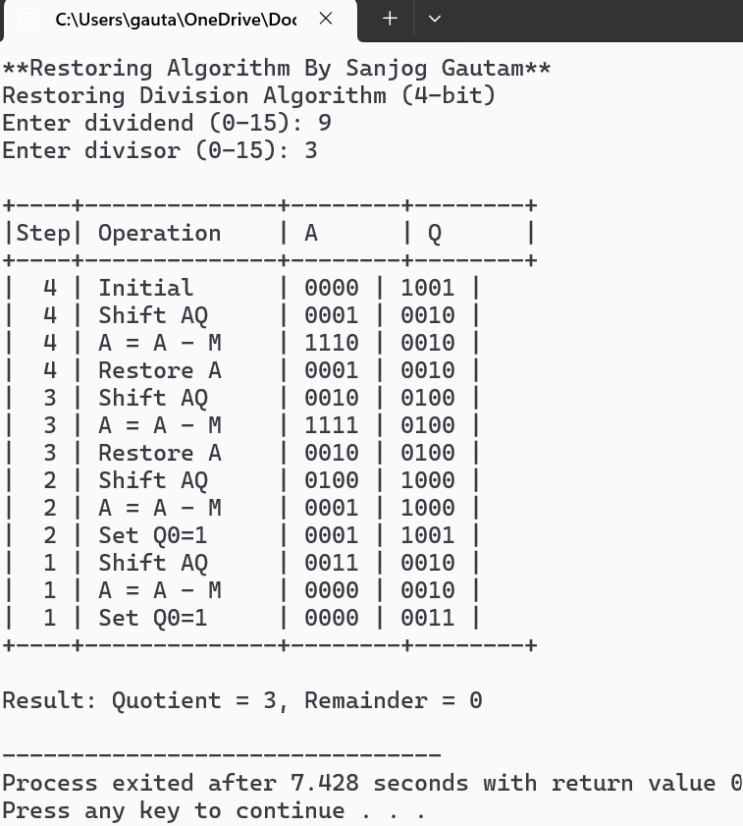

**Conclusion:**

The Restoring Division Algorithm provides a systematic method to divide binary numbers using shifting and subtraction. It is simple to implement in C and effectively handles unsigned binary division, giving accurate quotient and remainder.